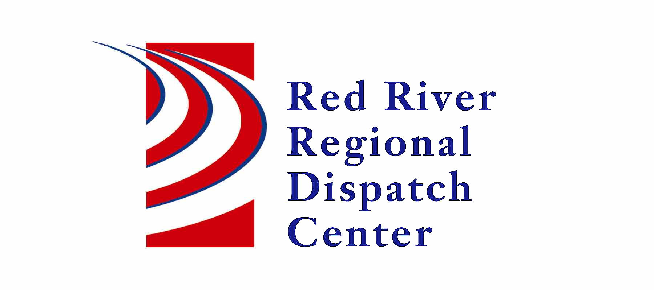

OOld

300 NP Avenue, Suite 206, Fargo, ND 58102
Administration 701-451-7680; Fax 701-451-7679
Mary Edinger, Operations Manager

RRRDC L.E. OPERATIONS COMMITTEE
July 17th, 2025
1430hrs
RRRDC 2nd Floor Conference Room

Agenda

Old Business:

- Signal 100’s for ND Agencies

- NCIC’s Violent Person File

New Business:

- Revision to SOP 200-001 Law Enforcement Radio Communications
- See attached pages 2-3 highlighted sections

- RRRDC New Facility Operations

- Other Business

Next Meeting: October 16th, 2025

