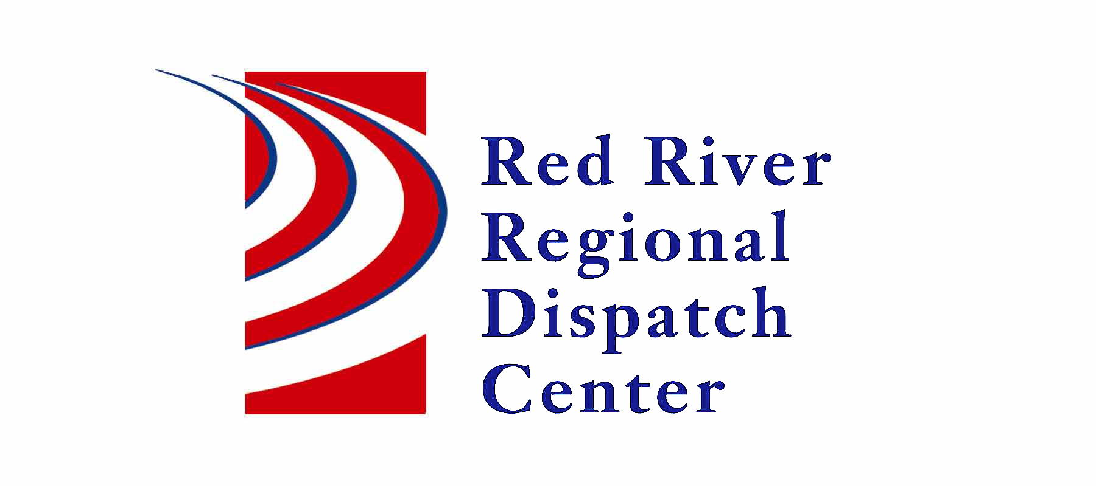

300 NP Avenue, Suite 206, Fargo, ND 58102
Administration 701-451-7680; Fax 701-451-7679

RRRDC FIRE/EMS OPERATIONS COMMITTEE
RRRDC 2nd Floor Conference Room
July 24th, 2025 1430hrs
Agenda

Old Business

- Dilworth Fire Response to Medicals in Dilworth
- Pipeline Call Guide - DRAFT

Agenda
- Call Times/Data
- Sanford Ambulance new blood protocols
- Map icons in New World mobile with drawings
- RRRDC New Facility Operations
- Open Discussion

Next Meeting: October 23rd 2025

