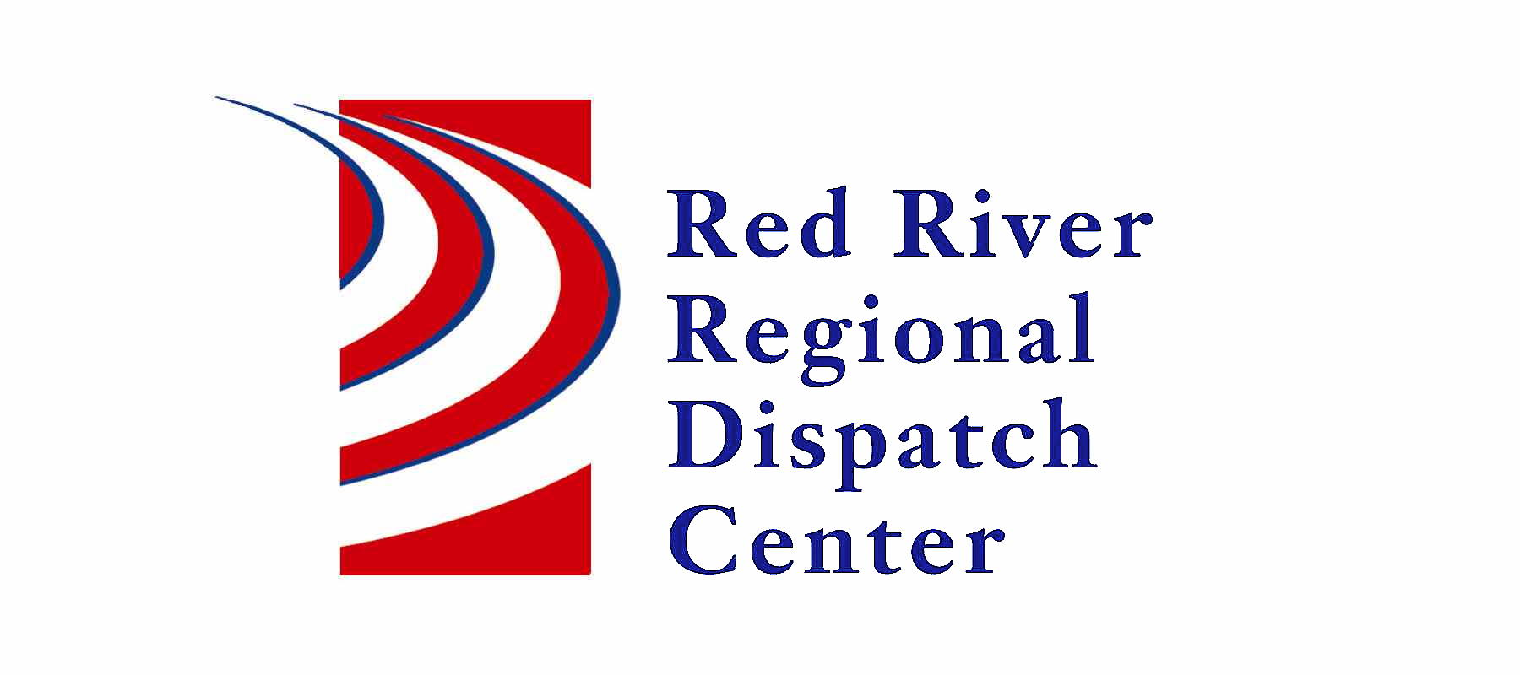

300 NP Avenue, Suite 206, Fargo, ND 58102
Administration 701-451-7680; Fax 701-451-7679

RRRDC FIRE/EMS OPERATIONS COMMITTEE
RRRDC 2nd Floor Conference Room
April 24rd, 2025 1430hrs
Agenda

Old Business

- Call Times/Data
- Medicals
- Red Cross

Agenda
- Call Times/Data
- Dilworth or Moorhead Fire Response to Medicals in Dilworth
- Pipeline Call Guide - DRAFT
- Open Discussion

Next Meeting: July 24th 2025

