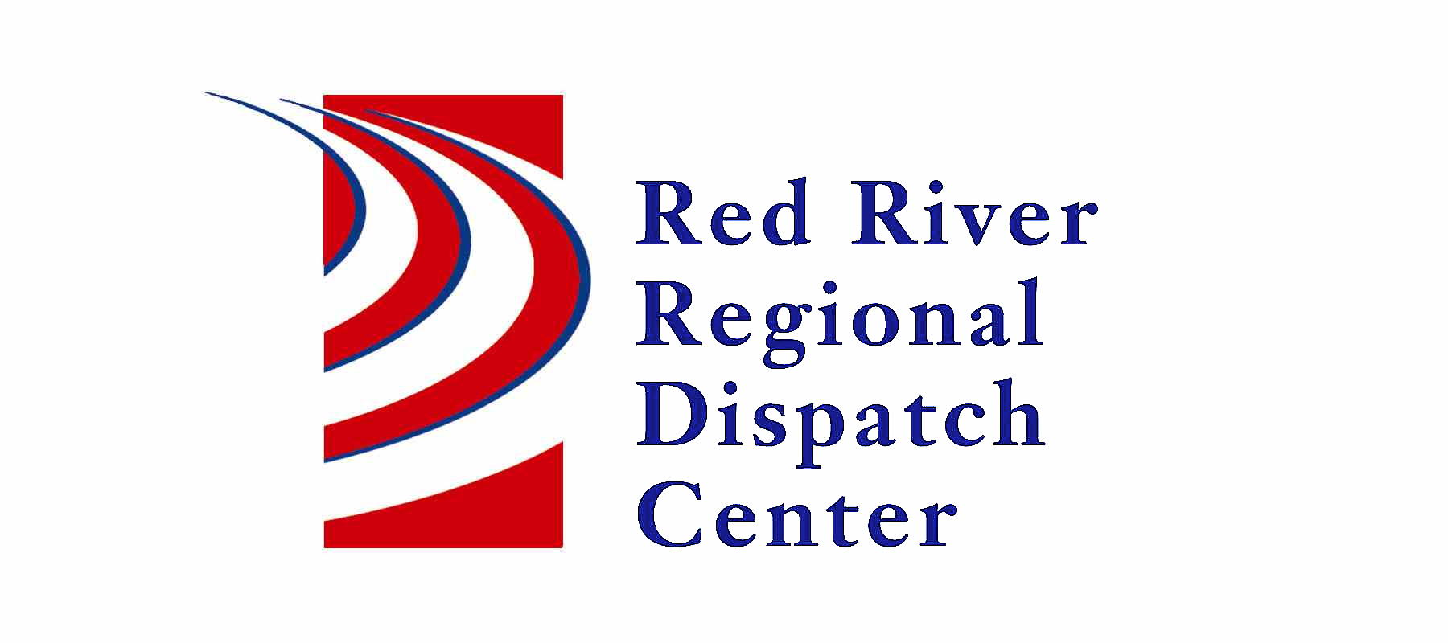

OOld

300 NP Avenue, Suite 206, Fargo, ND 58102
Administration 701-451-7684; Fax 701-451-7679
Kristi Kanski, Assistant Director

RRRDC L.E. OPERATIONS COMMITTEE
April 17th, 2025
1430hrs
RRRDC 2nd Floor Conference Room

Agenda

Old Business:

- Chair Position

- Criminal History form

- Property Accident Call guide update for MN agencies

New Business:

- Missing Person Call Guide

- Signal 100’s for ND agencies

- NCIC’s Violent Person File

- Other Business

Next Meeting: July 17th, 2025

