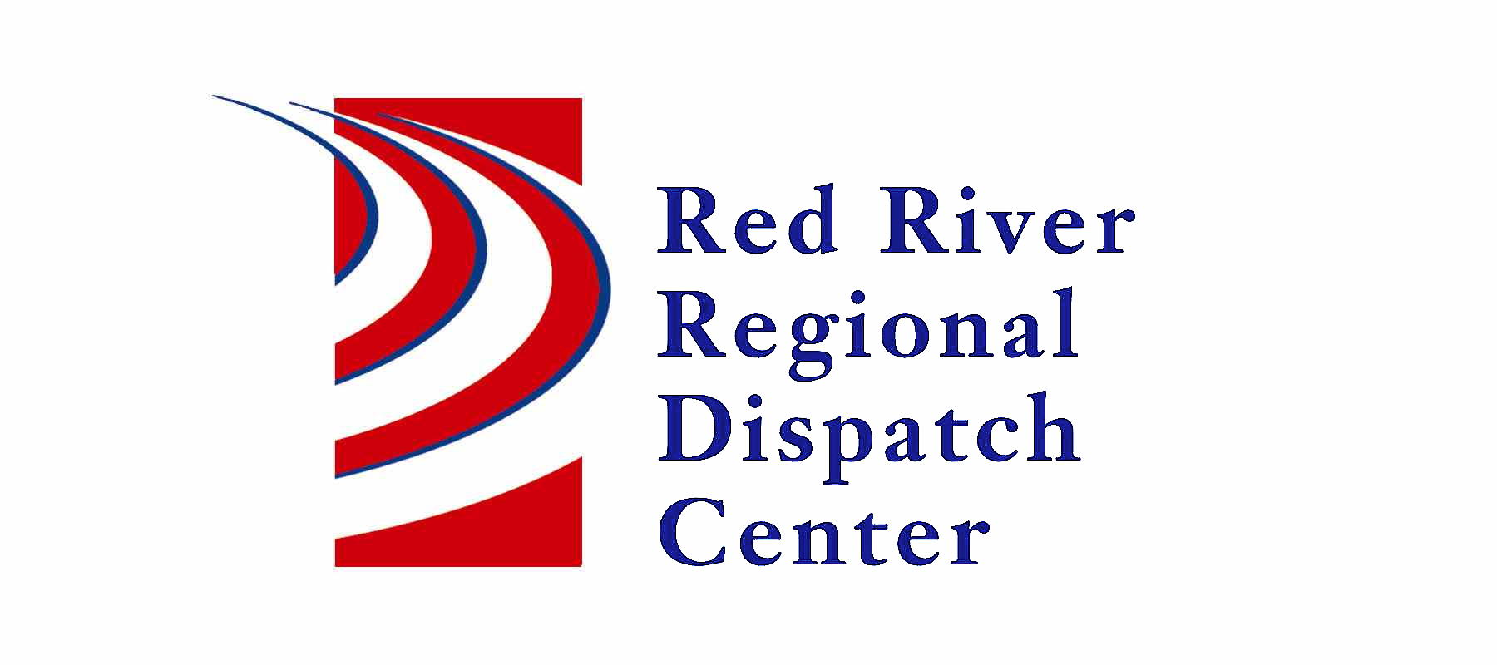

300 NP Avenue, Suite 206, Fargo, ND 58102
Administration 701-451-7680; Fax 701-451-7679

RRRDC FIRE/EMS OPERATIONS COMMITTEE
RRRDC 2nd Floor Conference Room
January 23rd, 2025 1430hrs
Agenda

Old Business

- Medicals

Agenda
- Call Times/Data
- RRRDC Year Review
- 2025 Meeting Dates (April 24th, July 24th, October 23rd)
- Open Discussion

Next Meeting: April 24th 2025

