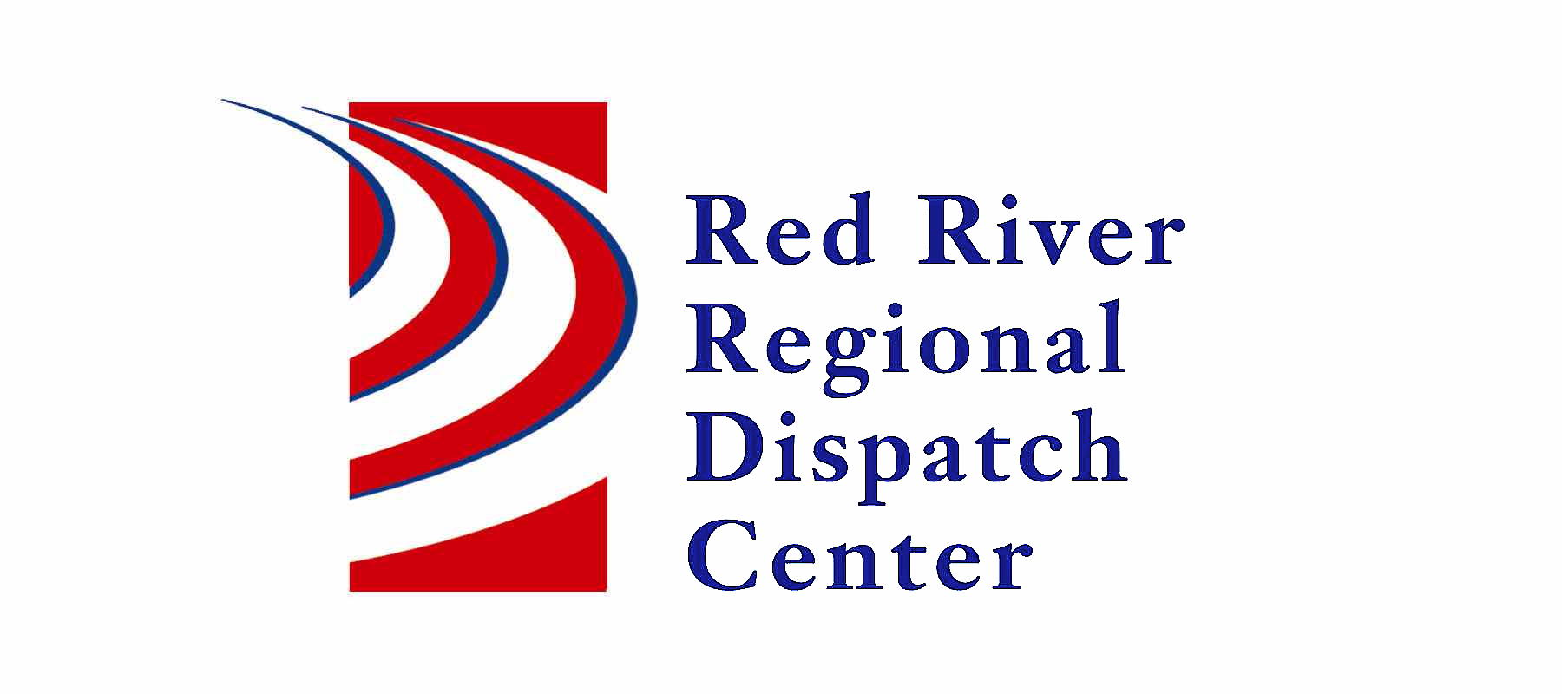

OOld

300 NP Avenue, Suite 206, Fargo, ND 58102
Administration 701-451-7684; Fax 701-451-7679
Kristi Kanski, Assistant Director

RRRDC L.E. OPERATIONS COMMITTEE
January 16th, 2025
1430hrs
RRRDC 2nd Floor Conference Room

Agenda

Old Business:

- Drone Activity

- Automatic Crash Notifications

- Key for abbreviations for Dispatch Log on RRRDC website

New Business:

- Chair Position

- Criminal History form

- Missing Person Call Guide

- 2024 Year Review

- 2025 Meeting Dates (April 17th, July 17th, Oct 16th)

- Other Business

Next Meeting: April 17th, 2025

