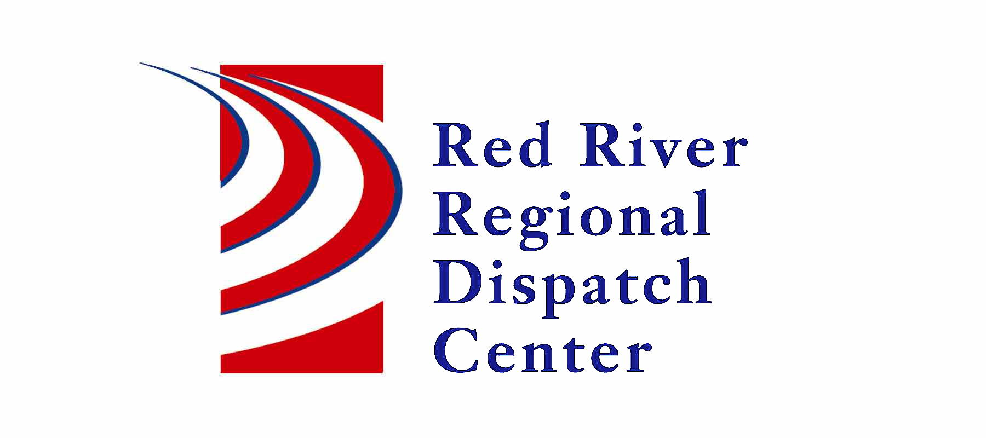

OOld

300 NP Avenue, Suite 206, Fargo, ND 58102
Administration 701-451-7684; Fax 701-451-7679
Kristi Kanski, Assistant Director

RRRDC L.E. OPERATIONS COMMITTEE
July 18th, 2024
1430hrs
RRRDC 2nd Floor Conference Room

Agenda

Old Business:

- Call Type Changes from ; 2022: Drone Activity (new) added; 2023: Narcotics/Health Safety Violations – updated.

New Business:

- New call type - Misc-Admin (request made by Cass County SO)

- Future Radio Operations
  - Data Channel

- Global Subject - Testing

- Automatic Crash Notifications

- Other Business

Next Meeting: October 17th

