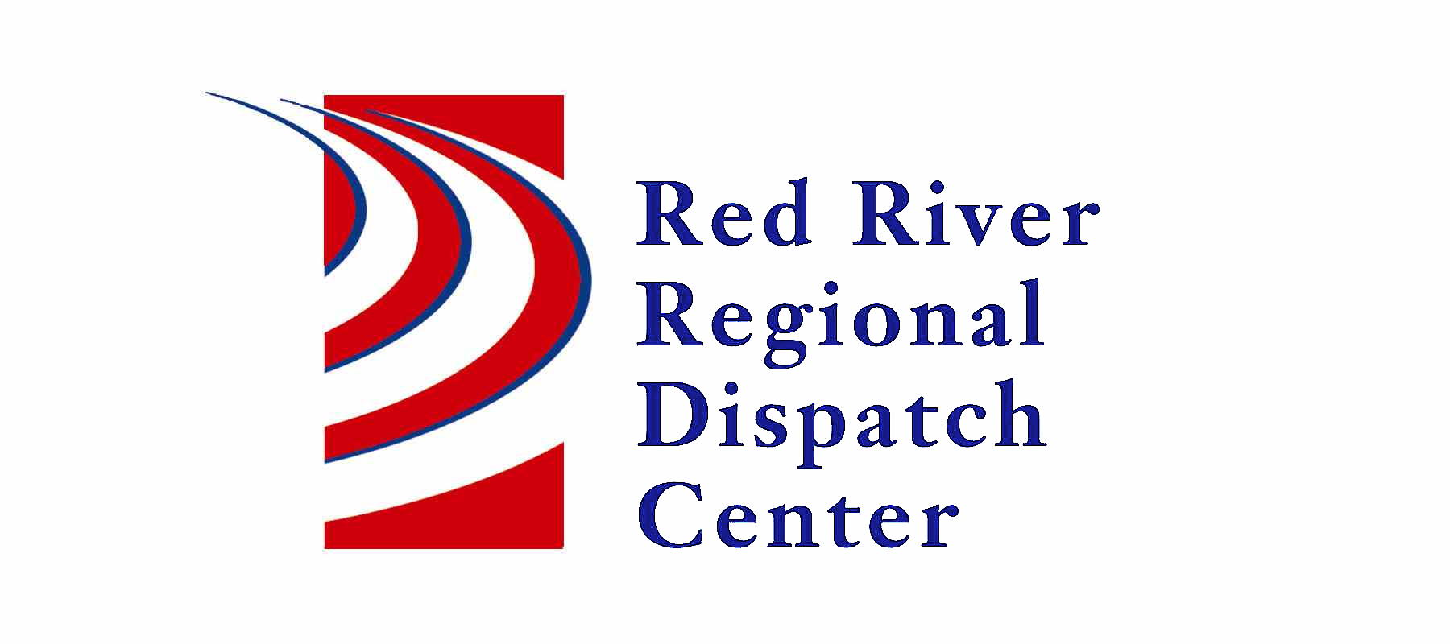

300 NP Avenue, Suite 206, Fargo, ND 58102
Administration 701-451-7680; Fax 701-451-7679

RRRDC FIRE/EMS OPERATIONS COMMITTEE
RRRDC 2nd Floor Conference Room
July 25th, 2024 1430hrs
Agenda
- Call Guides Updated – Misc. Fire, Odor Investigation, Mutual Aid, Health/Safety Violation, Bar Check, Compliance Check, Structure Fire (reformatted), Drone Activity 2023 – Pipeline Notification

Old Business

- Update to Vehicle Fire call guide

- Automatic Crash Notifications

Agenda
- Call Times/Data
- Data Channels
- Open Discussion

Next Meeting: October 24th, 2024

