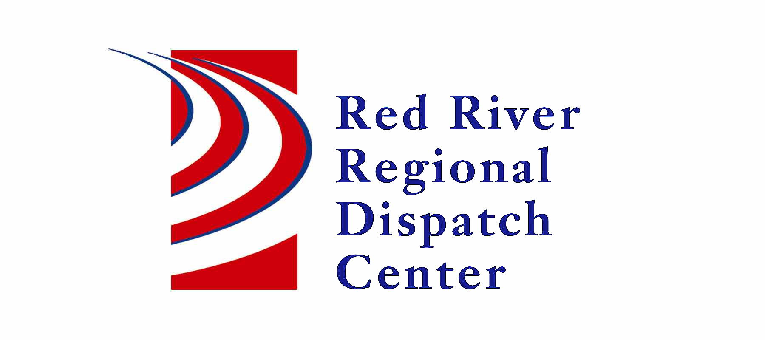

300 NP Avenue, Suite 206, Fargo, ND 58102
Administration 701-451-7680; Fax 701-451-7679
Mary Phillippi, Director

RRRDC FIRE/EMS OPERATIONS COMMITTEE
RRRDC 2nd Floor Conference Room
April 27th, 2023 1430hrs
Agenda

Old Business
- Call Guides Updated – Misc. Fire, Odor Investigation, Mutual Aid, Health/Safety Violation, Bar Check, Compliance Check, Structure Fire (reformatted), Drone Activity

New Business

- Election of LE Committee Chair
This individual will run the meeting and report to the Executive Committee

- Call Times

- Pipeline Notification – Potential Rupture

- Digital Paging Failures and back-up procedures

- Mental Health Dispatching – First Link update

- Open Discussion

Next Meeting: July 27th, 2023

