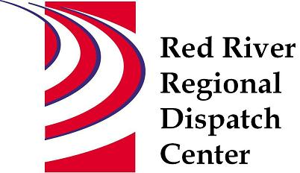

CHAIR
*Clay County Sheriff’s Office
Sheriff Mark Empting

VICE - CHAIR
*Fargo Fire Department
Chief Steve Dirksen

*Clay County Police Agencies
Chief Joe Backlund - Hawley PD

*Moorhead Police Department
Chief Shannon Monroe

*Cass County Sheriff’s Office
Sheriff Jesse Jahner

*West Fargo Police Department
Chief Denis Otterness

*Moorhead Fire Department
Interim Chief Jeff Wallin

*Fargo Police Department
Chief David Zibolski

FM Ambulance
Senior Director Tim Meyer

STAFF
Red River Regional Dispatch Center
Director Mary Phillippi

SECRETARY
Clay County
Heather Krone

*denotes voting member

January 9, 2023
9:00 AM
Remote Meeting
https://meet.goto.com/571469709
You can also dial in using your phone.
United States: +1 (408) 650-3123 Access Code: 571-469-709

- Call to order

- Approval of Agenda

- Approval of November 23, 2022 BOA minutes

- Adjourn

