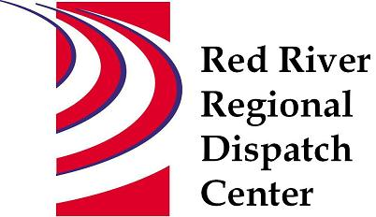

CHAIR
*Clay County Sheriff’s Office
Sheriff Mark Empting

VICE - CHAIR
*Fargo Fire Department
Chief Steve Dirksen

*Clay County Police Agencies
Chief Joe Backlund - Hawley PD

*Moorhead Police Department
Chief Shannon Monroe

*Cass County Sheriff’s Office
Sheriff Jesse Jahner

*West Fargo Police Department
Chief Denis Otterness

*Moorhead Fire Department
Interim Chief Jeff Wallin

*Fargo Police Department
Chief David Zibolski

FM Ambulance
Senior Director Tim Meyer

STAFF
Red River Regional Dispatch Center
Director Mary Phillippi

SECRETARY
Clay County
Heather Krone

*denotes voting member

August 24, 2022 1:30 P.M.
Clay County/Moorhead Law Enforcement Center
911 11 St N Moorhead, MN
Training Room
- Call to order

- Approval of the August 24, 2022 agenda
- Motion to approve/change agenda

- Review and approval of previous meeting minutes
- Motion to approve/change May 11, 2022 minutes

- Facility Planning – Chief Steve Dirksen

- New World update – Todd Keel

- Director’s Report

- Committee Reports
- Operations L.E – Chief Shannon Monroe Did not meet
- Operations Fire/EMS – Interim Chief Jeff Wallin Met July 28, 2022. Call times.
- Finance – Chief David Zibolski Did not meet
- Personnel - Chief Denis Otterness Met August 3, 2022 Current staffing levels, inquiries, complaints, recognition
- Emergency Communications – Sheriff Jesse Jahner Met July 27, 2022 FirstNet Update, Clay/Moorhead ARMER, Cass/Fargo West Fargo migration, communication issues, State of ND communications

- Other Business

- Adjourn

