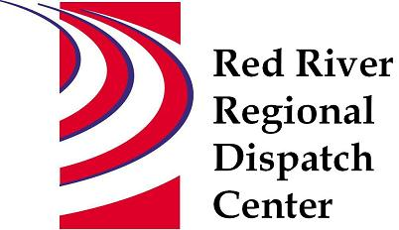

CHAIR
*Clay County Sheriff’s Office
Sheriff Mark Empting

VICE - CHAIR
*Fargo Fire Department
Chief Steve Dirksen

*Clay County Police Agencies
Chief Joe Backlund - Hawley PD

*Moorhead Police Department
Chief Shannon Monroe

*Cass County Sheriff’s Office
Sheriff Jesse Jahner

*West Fargo Police Department
Chief Denis Otterness

*Moorhead Fire Department
Interim Chief Jeff Wallin

*Fargo Police Department
Chief David Zibolski

FM Ambulance
Senior Director Tim Meyer

STAFF
Red River Regional Dispatch Center
Director Mary Phillippi

SECRETARY
Clay County
Heather Krone

*denotes voting member

May 11, 2022 1:30 P.M.
Clay County/Moorhead Law Enforcement Center
911 11 St N Moorhead, MN
Training Room
- Call to order

- Approval of the May 11, 20022 agenda
- Motion to approve/change agenda

- Review and approval of previous meeting minutes
- Motion to approve/change February 9, 2022 minutes

- Annual Conflict of Interest Statement

- Facility Planning – Chief Steve Dirksen

- New World update – Todd Keel

- Director’s Report

- Committee Reports
- Operations L.E – Chief Shannon Monroe Met April 20, 2022 Changing call types, Travis Law, Operations short staff, RRRDC Security, Phone Trace requirements.
- Operations Fire/EMS – Interim Chief Jeff Wallin Met April 28, 2022. Call times, Active Assailant response plans, ARMER, Fargo marathon.
- Finance Committee – Chief David Zibolski Met March 1, 2022 2021 expenses and revenues, 2022 YTD expenses and revenues, cash reserves, RRRDC CDs, NW maintenance formula
- Motion to forward to BOA for approval: Send contract for 401k advisor to Erik Johnson for legal review before approval.
- Motion to forward to BOA for approval: Complete an upgrade to the operating system in 2022 using cash reserves from RRRDC.
- Personnel and Finance Joint Committee Meeting – Chief David Zibolski and Chief Denis Otterness Met April 19, 2022 2023 Budget and Personnel Draft, 2022 YTD budget, RRRDC 401k update, Current staffing levels, Recruitment/Hiring, Inquiries/Complaints and Recognition, Security/Visitor SOP
- Motion: Recommend 2023 draft budget to BOA with COLA at 4% and increase shift differential from $.50 to $1.00 for an approximately $41,000 increase over draft budget.
- Emergency Communications – Sheriff Jesse Jahner No meeting this quarter

- Other Business

- Adjourn

