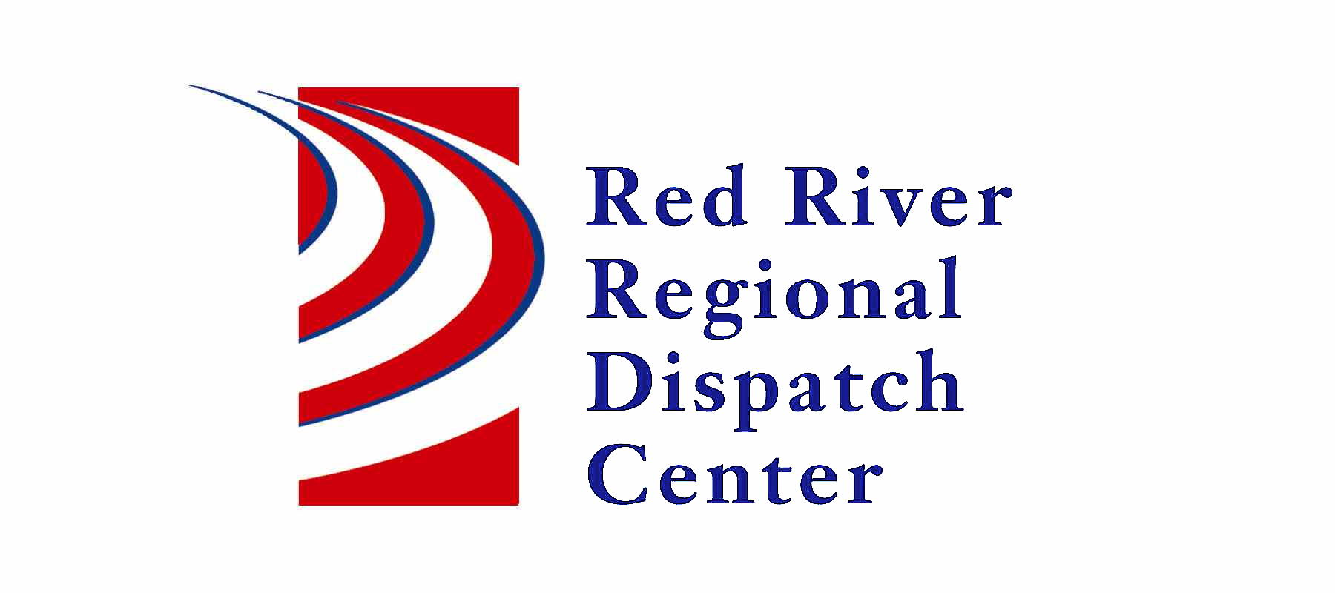

300 NP Avenue, Suite 206, Fargo, ND 58102
Administration 701-451-7680; Fax 701-451-7679
Mary Phillippi, Director

RRRDC FIRE/EMS OPERATIONS COMMITTEE
RRRDC 2nd Floor Conference Room
April 28th, 2022 1430hrs
Agenda

Old Business
- Call Guides Updated – Misc. Fire, Odor Investigation, Mutual Aid, Health/Safety Violation, Bar Check, Compliance Check, Structure Fire (reformatted), Drone Activity
- Harwood Fire/Rescue Mobile
- AirMed Auto-Launch
- Status Check on working fires
- Suicidal Subject – EMS Response

New Business

- Call Times
- Active Assailant – Response plans
- ARMER
- Open Discussion

Next Meeting: July 28th, 2022

