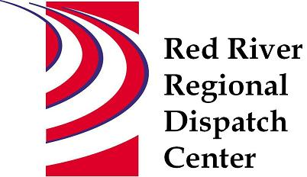

CHAIR
*Clay County Sheriff’s Office
Sheriff Mark Empting

VICE - CHAIR
*Fargo Fire Department
Chief Steve Dirksen

*Clay County Police Agencies
Chief Joe Backlund - Hawley PD

*Moorhead Police Department
Chief Shannon Monroe

*Cass County Sheriff’s Office
Sheriff Jesse Jahner

*West Fargo Police Department
Chief Denis Otterness

*Moorhead Fire Department
Interim Chief Jeff Wallin

*Fargo Police Department
Chief David Zibolski

FM Ambulance
Senior Director Tim Meyer

STAFF
Red River Regional Dispatch Center
Director Mary Phillippi

SECRETARY
Clay County
Heather Krone

*denotes voting member

February 9, 2022 1:30 P.M.
Clay County/Moorhead Law Enforcement Center
911 11 St N Moorhead, MN
Training Room
- Call to order

- Approval of the February 9, 2022 agenda
- Motion to approve/change agenda

- Review and approval of previous meeting minutes
- Motion to approve/change November 10,2021 minutes

- Election of Chair and Vice Chair for 2022

- Selections of Chairpersons for 2022 Standing Committees

- Annual Conflict of Interest Statement

- Facility Planning – Chief Steve Dirksen

- New World update – Todd Keel

- Air MED Auto Launch

- Director’s Report

- Committee Reports
- Operations L.E – Chief Shannon Monroe Met January 20, 2022 Drone call type, changing call types, Travis Law, Mobile Mental Health disposition, Covid and operations, MN Teletype JPA.
- Motion to forward to BOA for approval: Approve State of Minnesota Joint Powers Agreement with RRRDC BOA for connectivity to systems.
- Operations Fire/EMS – Interim Chief Jeff Wallin Met January 27, 2022 Call Call times, Status checks, Drone activity call guide, Suicidal person, Mobile mental health, responders making phone calls, Air MED auto launch, ARMER, River rescue dispatch,
- Personnel – Chief Denis Otterness Met February 2, 2022 Current staffing levels and hiring, Inquiries/Complaints and Recognition, 2021 year review
- Finance Committee – Chief David Zibolski Met on January 4, 2022 401(k) provider analysis, 2021 YTD expenses and revenues, cash reserves, RRRDC CDs, NW maintenance formula
- Motion to forward to BOA for approval: Accept recommendation to move to Alerus as RRRDC 401 provider.
- Motion to forward to BOA for approval: Leave funds in RRRDC CD and use for new facility.
- Emergency Communications – Sheriff Jesse Jahner Met January 25, 2022 FirstNet update, Clay Moorhead ARMER, Cass County, Fargo West Fargo 800 migration. ND Statewide Communications

- Other Business

- Adjourn

