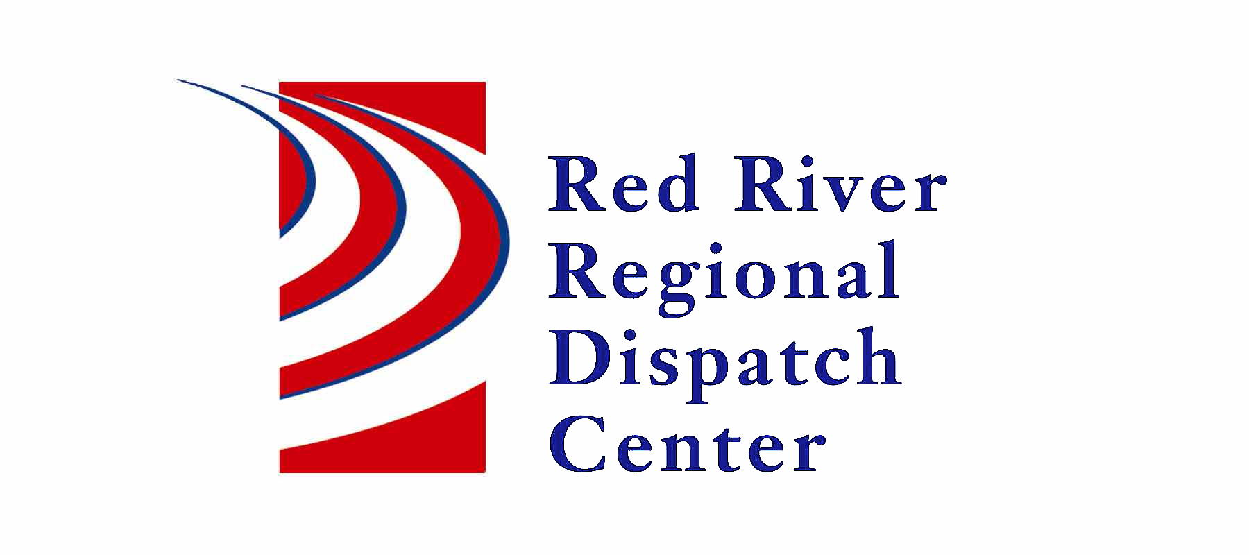
OOld

300 NP Avenue, Suite 206, Fargo, ND 58102
Administration 701-451-7680; Fax 701-451-7679
Mary Phillippi, Director

RRRDC L.E. OPERATIONS COMMITTEE
January 20, 2022

Agenda
Virtual Meeting Option: https://global.gotomeeting.com/join/476735277
Old Business:

- Call Type Changes from 2021: Offender Check, License Premise Inspection, CV, PO, EV, RV – added
- Drone Call Type - Draft
- ND ARMER – Reminder that Brian & Amanda are available for trainings!

New Business:
- Changing call types

- Travis’s Law

  - Mobile Mental Health Disposition – Added

- COVID & Operations

- Other business

Next meeting – April 21st, 2022
