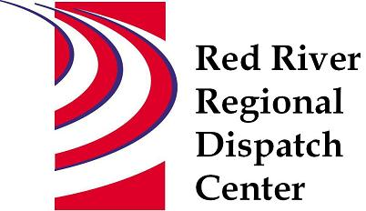

CHAIR
*Clay County Sheriff’s Office
Sheriff Mark Empting
VICE - CHAIR
*Fargo Fire Department
Chief Steve Dirksen

*Clay County Police Agencies
Chief Joe Backlund - Hawley PD

*Moorhead Police Department
Chief Shannon Monroe

*Cass County Sheriff’s Office
Sheriff Jesse Jahner

*West Fargo Police Department
Chief Denis Otterness

*Moorhead Fire Department
Interim Chief Jeff Wallin

*Fargo Police Department
Chief David Zibolski

FM Ambulance
Senior Director Tim Meyer

STAFF
Red River Regional Dispatch Center
Director Mary Phillippi

SECRETARY
Clay County
Robin Rummel

*denotes voting member

August 26, 2020 3:00 PM
Remote Meeting
https://global.gotomeeting.com/join/185286461
United States: +1 (224) 501-3412 Access Code: 185-286-461

- Call to order

- Approval of agenda

- RRRDC Financial Cost Share - 2020 Census

- Adjourn

