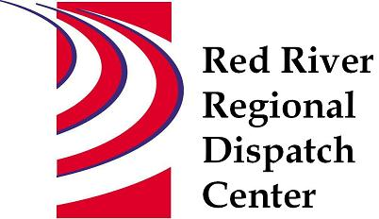

CHAIR
*Clay County Sheriff’s Office
Sheriff Mark Empting
VICE - CHAIR
*Fargo Fire Department
Chief Steve Dirksen

*Clay County Police Agencies
Chief Joe Backlund - Hawley PD

*Moorhead Police Department
Chief Shannon Monroe

*Cass County Sheriff’s Office
Sheriff Jesse Jahner

*West Fargo Police Department
Chief Denis Otterness

*Moorhead Fire Department
Interim Chief Jeff Wallin

*Fargo Police Department
Chief David Zibolski

FM Ambulance
Senior Director Tim Meyer

STAFF
Red River Regional Dispatch Center
Director Mary Phillippi

SECRETARY
Clay County
Robin Rummel

*denotes voting member

August 11, 2021 1:30 P.M.
Clay County/Moorhead Law Enforcement Center
911 11 St N Moorhead, MN
Training Room
- Call to order

- Approval of the August 11, 2021 agenda
- Motion to approve/change agenda

- Review and approval of previous meeting minutes
- Motion to approve/change May 12,2021 minutes

- Facility Planning – Chief Steve Dirksen

- New World update – Nick Lindhag

- Director’s Report

- Committee Reports
- Operations L.E – Chief Shannon Monroe Met July 15, 2021 Call type request for serving papers civil, protection orders, evictions, and ATV/UTV/Snowmobile/RV, ND ARMER, NCIC clear entries fax, MN Public Safety Bill Mental Health, Phone calls to mobile detox, jail, cabs, etc.
- Operations Fire/EMS – Interim Chief Jeff Wallin Met August 5, 2021 Call times, Horace Fire request, Harwood MDC, AIRMED STAC assignment, ARMER, Structure Fire Call Guide Format, Red Cross
- Personnel – Chief Denis Otterness Met August 4, 2021: Current staffing levels, recruitment/hiring, inquires and recognition.
- Finance Committee – Chief David Zibolski Met on July 6, 2021 2020 Budget and expenses, 2022 budget approved by BOA, 2021 YTD expenses and revenues, update cash reserves, RRRDC 401k fee audit, annual RRRDC audit.
  - Motion made and approved to move forward with 401k fee audit and pay for it from cash reserves
  - Motion made and approved to continue using Widmer Roel for RRRDC audit.
- Emergency Communications – Sheriff Jesse Jahner Met July 27, 2021 FirstNet update, Clay/Moorhead ARMER, Cass County/Fargo ND ARMER, ND SIRN, Planned Event Communications

- Other Business

- Adjourn

Next Meeting Scheduled for November 10, 2021

